Michael Rizzo

11/13/2014

Continuous Methods

Lab 5 Part 2 Question 3,4,5

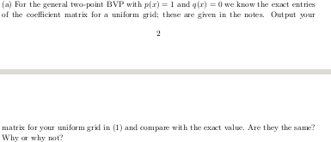

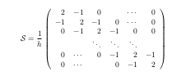
Exact Matrix

Matrix I got

[[ 8. -4. 0. 0. 0. 0. 0.]
[-4. 8. -4. 0. 0. 0. 0.]
[ 0. -4. 8. -4. 0. 0. 0.]
[ 0. 0. -4. 8. -4. 0. 0.]
[ 0. 0. 0. -4. 8. -4. 0.]
[ 0. 0. 0. 0. -4. 8. -4.]
[ 0. 0. 0. 0. 0. -4. 8.]]

let h= and the exact matrix will be the matrix I got. The stiffness matrix depends on the values of the derivative basis function. The results are the same because the derivative value of the basis function is or

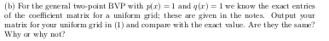

Exact Matrix

8.16667 -4.04167 0.00000 0.00000 0.00000 0.00000 0.00000
-4.04167 8.16667 -4.04167 0.00000 0.00000 0.00000 0.00000
0.00000 -4.04167 8.16667 -4.04167 0.00000 0.00000 0.00000
0.00000 0.00000 -4.04167 8.16667 -4.04167 0.00000 0.00000
0.00000 0.00000 0.00000 -4.04167 8.16667 -4.04167 0.00000
0.00000 0.00000 0.00000 0.00000 -4.04167 8.16667 -4.04167
0.00000 0.00000 0.00000 0.00000 0.00000 -4.04167 8.16667

The matrix I got

[[ 8.125 -3.9375 0. 0. 0. 0. 0. ]
[-3.9375 8.125 -3.9375 0. 0. 0. 0. ]
[ 0. -3.9375 8.125 -3.9375 0. 0. 0. ]
[ 0. 0. -3.9375 8.125 -3.9375 0. 0. ]
[ 0. 0. 0. -3.9375 8.125 -3.9375 0. ]
[ 0. 0. 0. 0. -3.9375 8.125 -3.9375]
[ 0. 0. 0. 0. 0. -3.9375 8.125 ]]

The values are not the same because the mass matrix used was approximated by a one point gauss quadrature rule.

4.

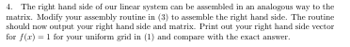

Right hand side I Got
[[ 0.25]
[ 0.25]
[ 0.25]
[ 0.25]
[ 0.25]
[ 0.25]
[ 0.25]]

Exact Matrix
rhs =

0.25000 0.25000 0.25000 0.25000 0.25000 0.25000 0.25000

Both right hand sides are exactly the same.

5.

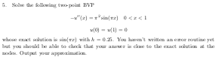

My Solution

[[ 0.68792453]
[ 0.97287221]
[ 0.68792453]]

Exact_solution

0.70711 1.00000 0.70711

Graphs for 5,9,17,33, and 65 nodes

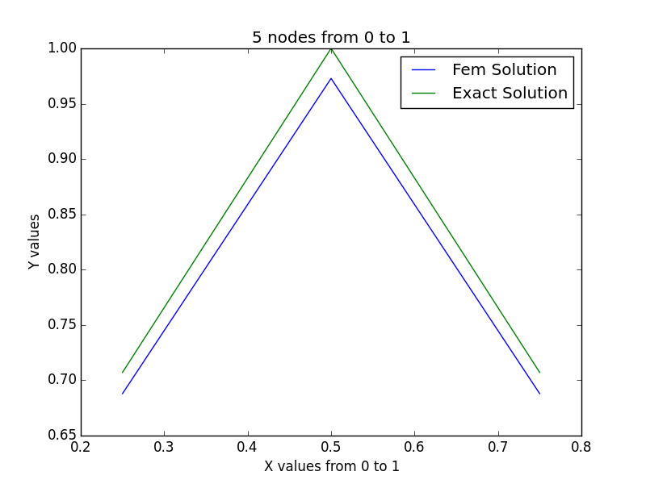
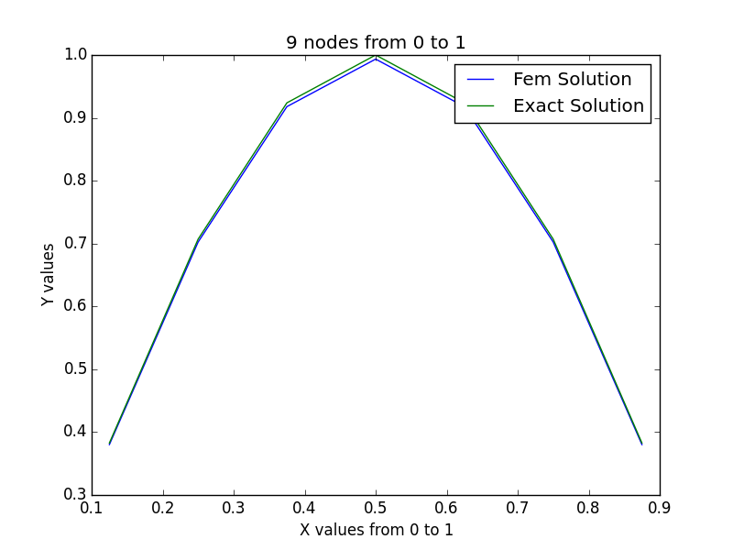

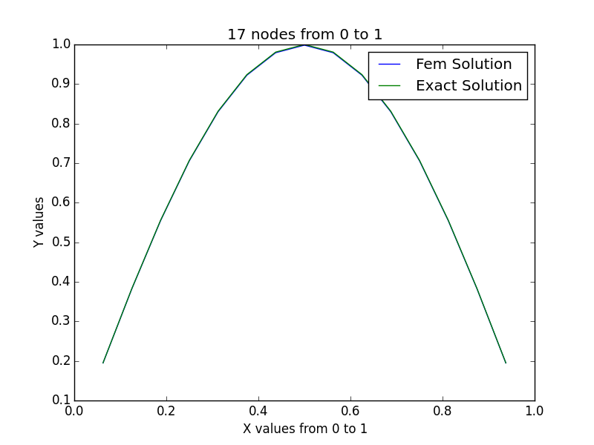
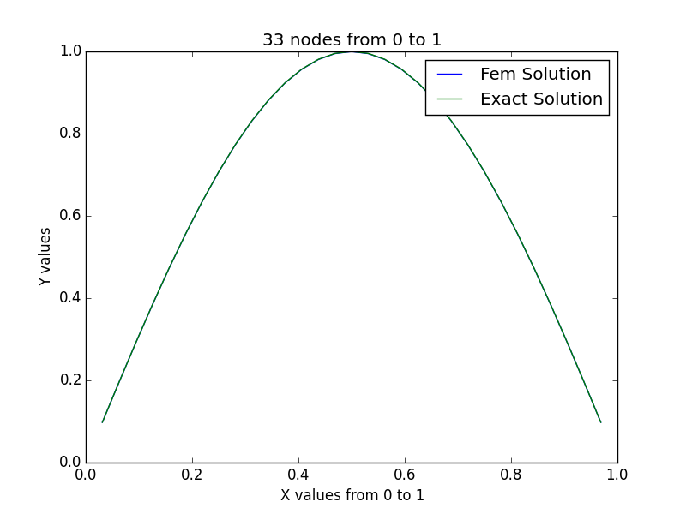

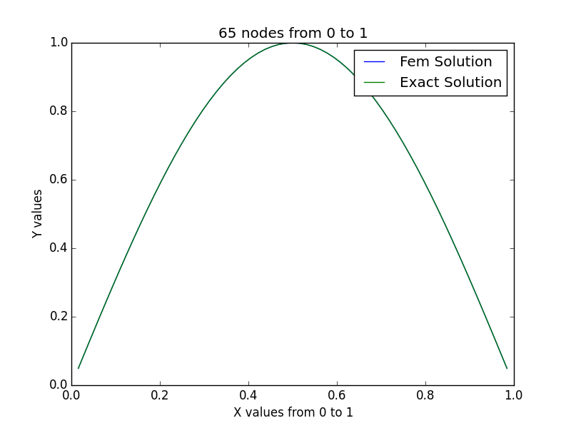

Convergence Rates and errors for 5,9,17,33, and 65 nodes

Number Of Nodes | Error | Convergence Rate
5 | 5.39018339046*10^-2 | 0
9 | 1.35922704922*10^-2 | 1.9875478905032724
17 | 3.40526054443*10^-3 | 1.9969493766544835
33 | 8.51762997571*10^-4 | 1.9992412238568733
65 | 2.12968714201*10^-4 | 1.999810548041891

